Seta carro

Código:

// C++ code

//

const int btn1 = 3;

const int btn2 = 4;

const int btn3 = 5;

int cbtn1State = 0;

int cbtn2State = 0;

int cbtn3State = 0;

void setup()

{

pinMode(btn1, INPUT);

pinMode(btn2, INPUT);

pinMode(btn3, INPUT);

pinMode(0, OUTPUT); // dianteiro esquerdo

pinMode(1, OUTPUT); // dianteiro direito

pinMode(2, OUTPUT); // traseiro esquerdo

pinMode(6, OUTPUT); // traseiro direito

}

void loop()

{

cbtn1State = digitalRead(btn1);

cbtn2State = digitalRead(btn2);

cbtn3State = digitalRead(btn3);

if(cbtn1State == HIGH) {

digitalWrite(0, HIGH);

digitalWrite(1, HIGH);

digitalWrite(2, HIGH);

digitalWrite(6, HIGH);

delay(600);

digitalWrite(0, LOW);

digitalWrite(1, LOW);

digitalWrite(2, LOW);

digitalWrite(6, LOW);

delay(600);

}

if(cbtn2State == HIGH) {

digitalWrite(0, HIGH);

digitalWrite(1, LOW);

digitalWrite(2, HIGH);

digitalWrite(6, LOW);

delay(600);

digitalWrite(0, LOW);

digitalWrite(1, LOW);

digitalWrite(2, LOW);

digitalWrite(6, LOW);

delay(600);

}

if(cbtn3State == HIGH) {

digitalWrite(0, LOW);

digitalWrite(1, HIGH);

digitalWrite(2, LOW);

digitalWrite(6, HIGH);

delay(600);

digitalWrite(0, LOW);

digitalWrite(1, LOW);

digitalWrite(2, LOW);

digitalWrite(6, LOW);

delay(600);

}

}

Pisca – alerta:

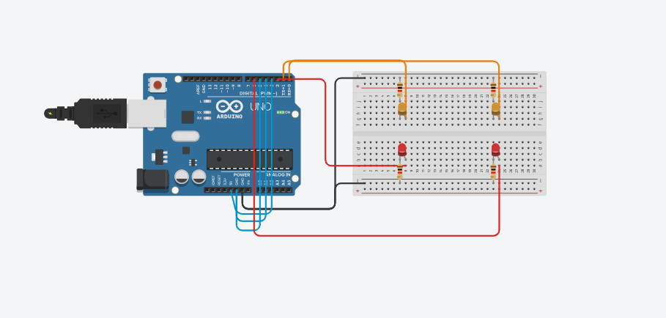

Seta esquerda

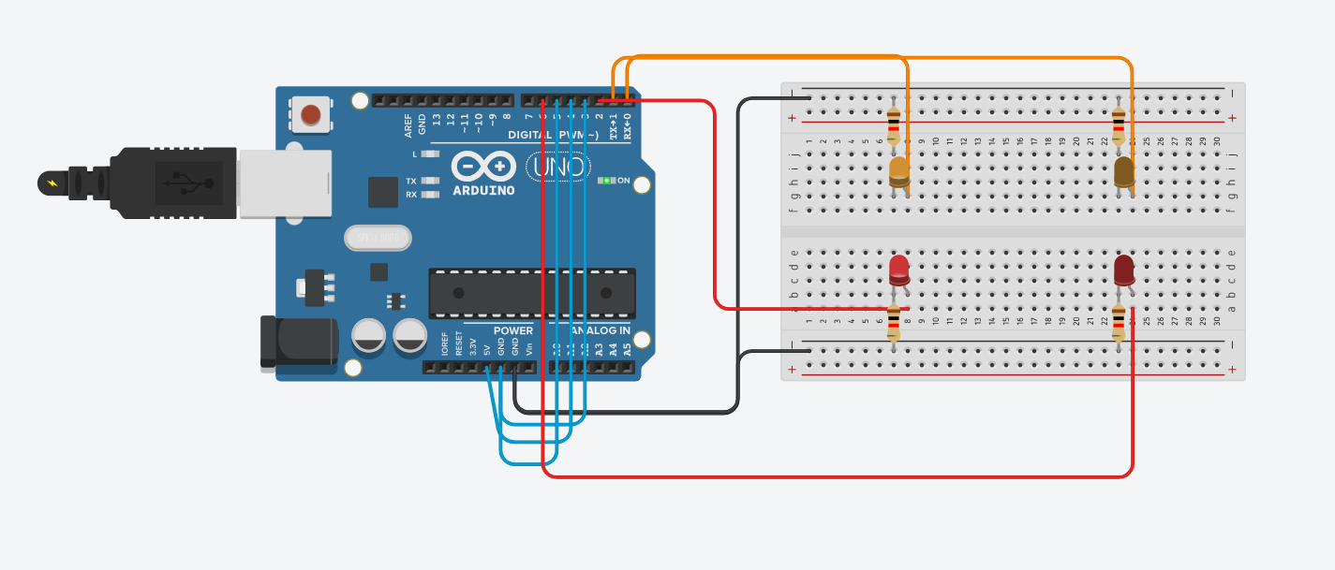

# 

Seta direita